INGLÊS - ELEMENTARY III (Activities week 1 – June 2020)
______________________________________________________________

Learn/Practice English with MOVIES (Lesson #4) Title: Finding Nemo

https://www.youtube.com/watch?v=5SfQhkMsUFk

At the Restaurant Conversation
https://www.youtube.com/watch?v=bgfdqVmVjfk

How to THINK in English | No More Translating in Your Head!
https://www.youtube.com/watch?v=SJOnhWiJArM

Listening Activity:

Click on the link below to listen to two friends talking about going to see a film and then choose the correct answer to the questions:

https://www.cambridgeenglish.org/learning-english/activities-for-learners/a1l002-going-to-the-movies

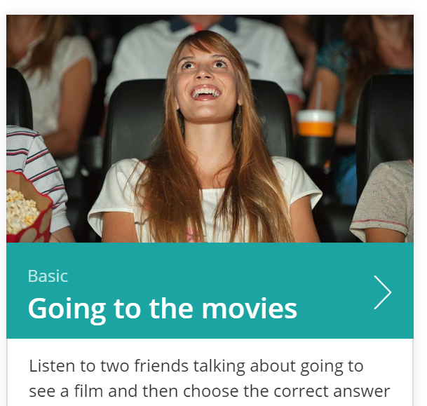
_________________________________________________________________________________

https://en.islcollective.com/english-esl-worksheets/grammar/past-simple-or-past-continuous-tense/arent-firefighters-cool-reading-comprehension-grammar-compar/3443

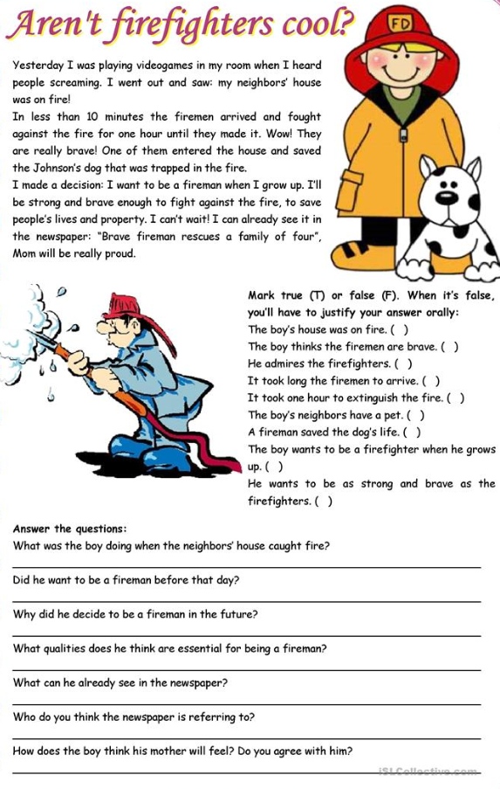

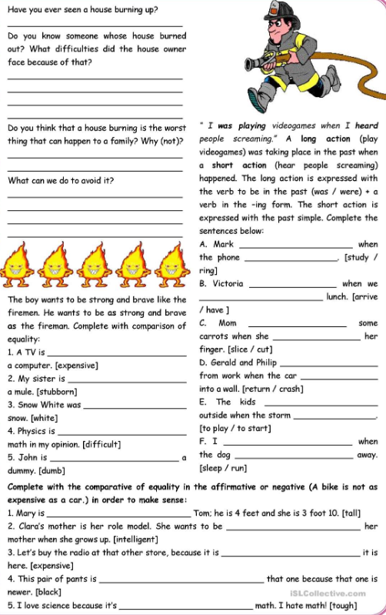

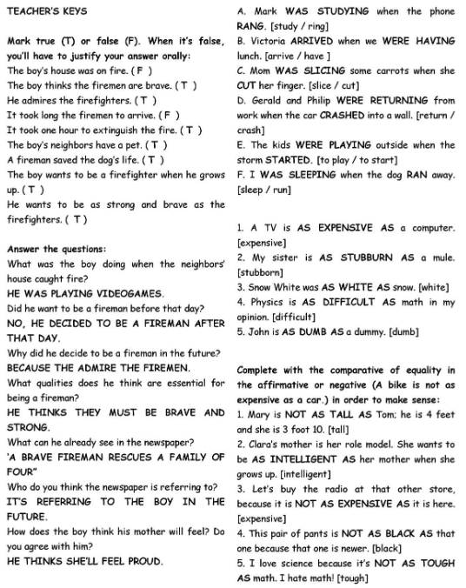

Kátia Vecchi – kcjvecchi@uem.com
__________________________________________________________________________________________

